How to Register for Avera vCNE courses

Go to the Avera Events & Live Courses site: https://avera.cloud-cme.com/aph.aspx?P=1000
Once there, select the Avera Virtual Continuing Nursing Education (vCNE) Series by clicking ‘Register’:
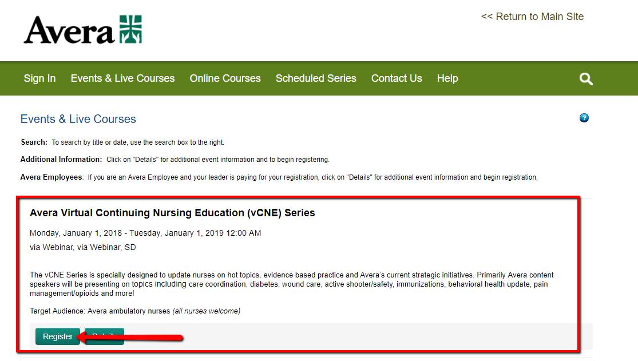

**As a reminder, the AAMA has currently only approved the Thursday April 26th, 2018 vCNE event to be eligible for AAAM CEUs**
However, if we have great MA attendance for these vCNE events the Avera Education Department will continue to work with the AAMA in continuing to have these vCNE’s count for AAMA CEU credits.
*ATTENTION RMAs: The AMT does accept CEU’s approved by the AAMA. You will need to submit your attendance to these vCNE’s to the AMT at the time you are due for renewal for these credits*

Once selected the following screen will display. Choose ‘Login or Create a New Account’
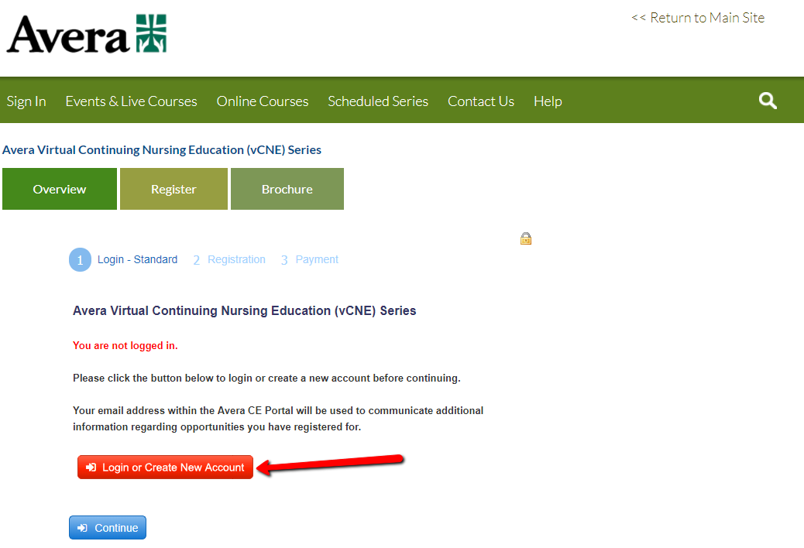
New users: click the “Don’t have an account” and follow the prompts in creating a new account
Returning users: enter in the e-mail address and password used for Avera vCNE registrations
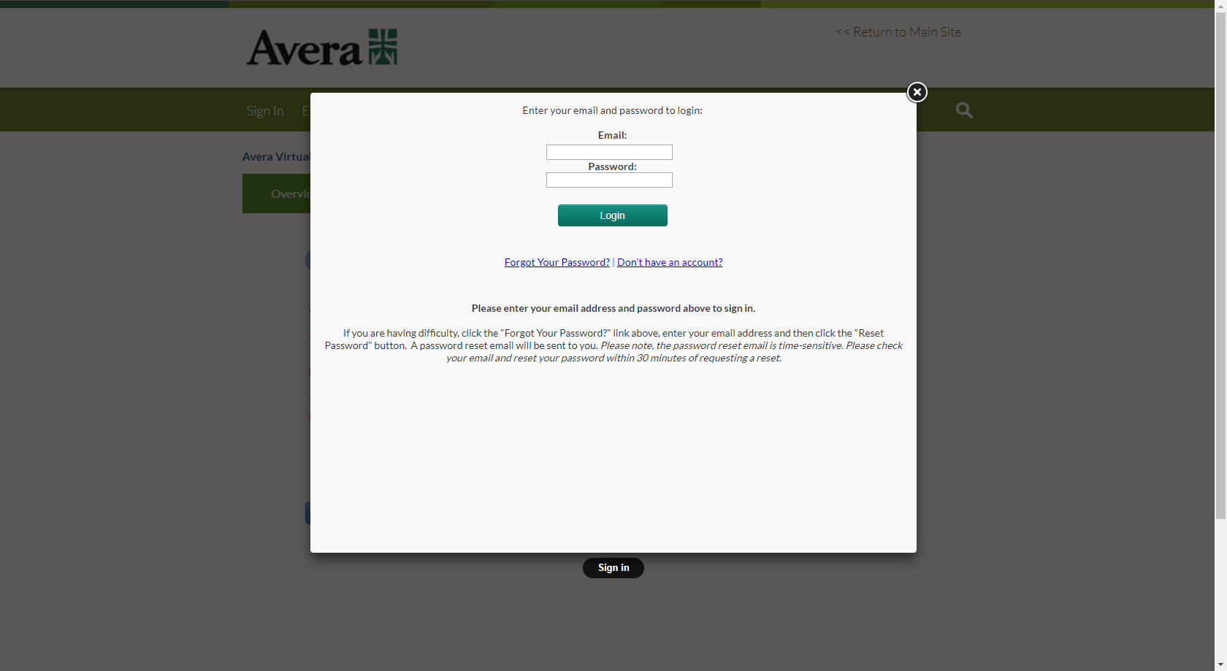
Once logged in the following screen will display indicating the user is now logged in. Select ‘Continue’ to register for the course.
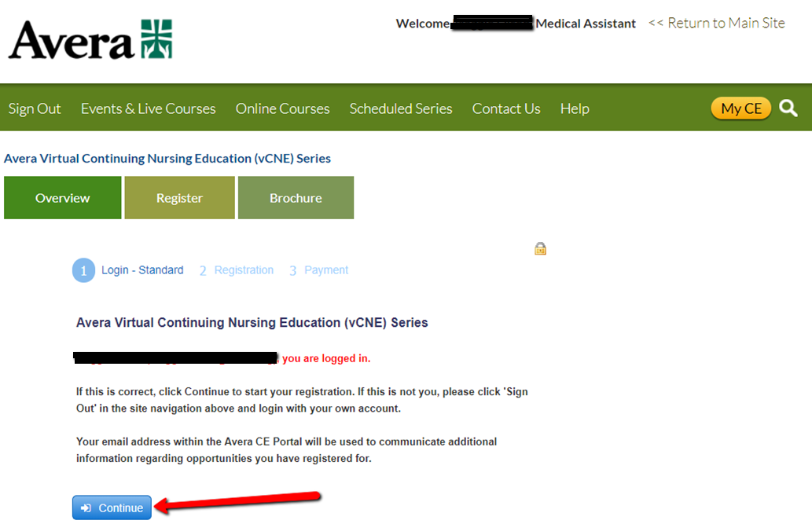
The following ‘Registration Type’ screen will then prompt; due to these events being free, click ‘continue’
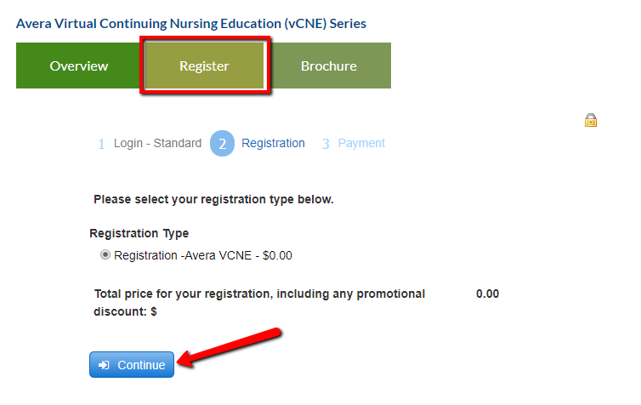
The ‘Payment’ screen will then prompt. Again, these events are free so click ‘Finish’ to complete the registration process.
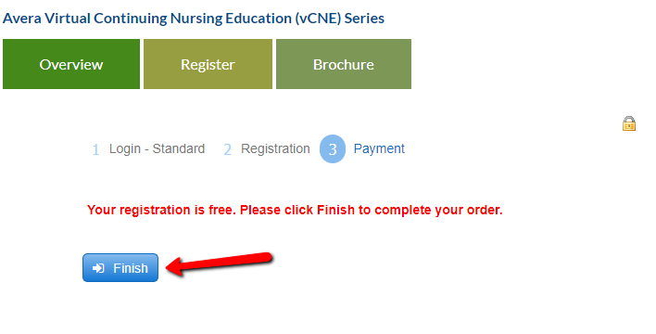
To receive an e-mail of the receipt of your registration, select ‘send’ as pictured below:
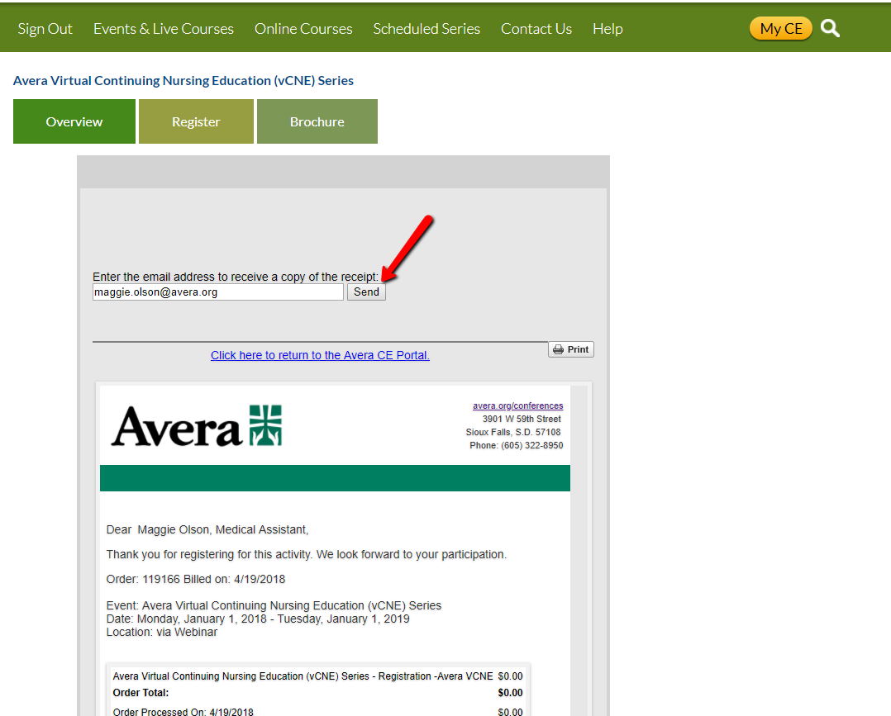

If you pressed send, the below screen will populate
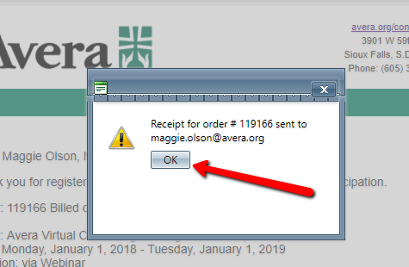
You will receive an e-mail, promptly, with the receipt of your registration:
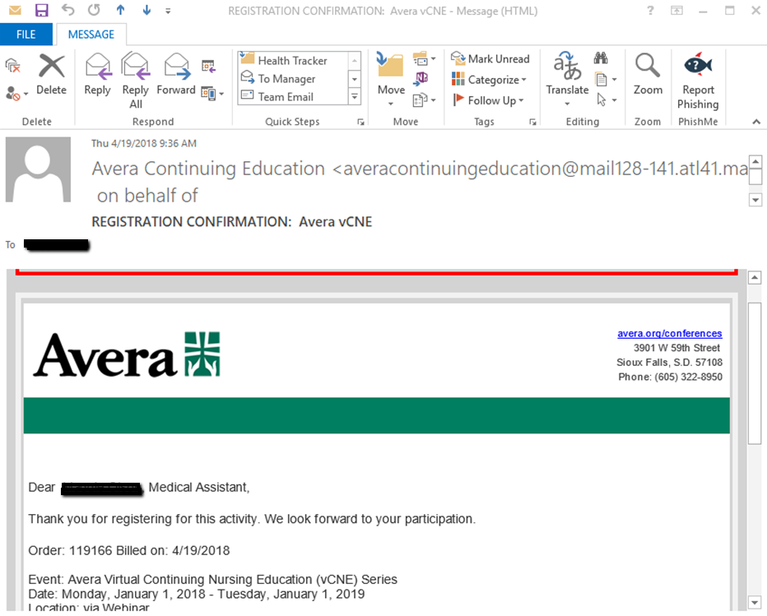

You may also receive a PDF version of the receipt.
